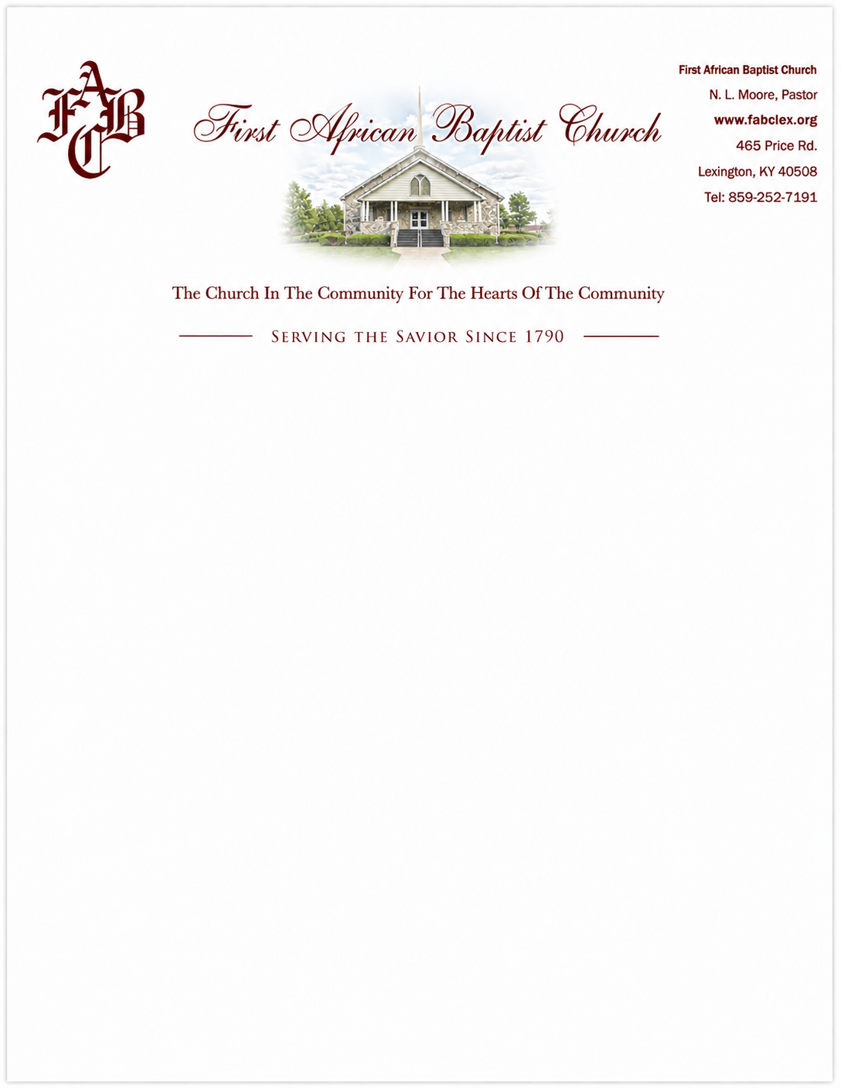

Biographical Profile
Rev. Dr. Nathl L. Moore
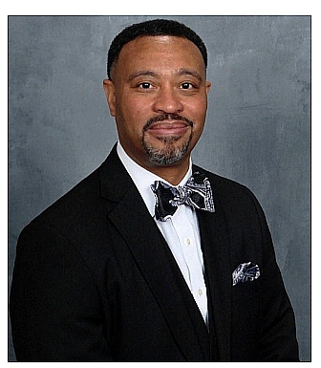
Rev. Dr. Nathl L. Moore is a native of Huntsville, Alabama, and the son of Harold and Delois Moore. He is married to the former Evelyn Faye Scott, a native of Pittsburgh, Pennsylvania. Together, they are the proud parents of four children and grandparents of five.
Pastor Moore accepted Christ as his Lord and Savior and was baptized at St. Luke Missionary Baptist Church in Huntsville. He acknowledged his call to preach the gospel on December 6, 1998. He was licensed to preach on October 31, 1999, and ordained into the pastoral ministry on September 8, 2002, at New Life Missionary Baptist Church in Cincinnati, Ohio.
Academically, Pastor Moore graduated from Tuskegee University in May 1996 with a Bachelor of Science in Computer Science. Furthering his theological education, he earned his Master of Divinity from Lexington Theological Seminary in May 2011, and his Doctor of Ministry (D.Min.) from United Theological Seminary in Dayton, Ohio, in May 2017.
Reverend Moore began his ministerial career in August 2000 as the Pastor-Administrator of Christ’s Community In College Hill, an ecumenical outreach ministry in Cincinnati. He subsequently served as the pastor of Centerville Missionary Baptist Church from August 2002 to August 2009. Today, he proudly serves as the 14th Pastor of First African Baptist Church.
Beyond his pastoral duties, Dr. Moore is a dedicated educator and servant leader. He has served as an instructor, workshop leader, and class facilitator for numerous local, state, and regional conferences. He is the former Moderator of the Consolidated Baptist District Association and presently serves as the 1st Vice Moderator of the General Association of Baptists in Kentucky. Pastor Moore currently serves on the Board of Trustees for Lexington Theological Seminary and as an Advisor and Reader for the Doctor of Ministry program. Pastor Moore also serves as Co-Chair of BUILD (Building a United Interfaith Lexington through Direct-Action), a Lexington-based social justice ministry.

